**Educational Organisation Using ServiceNow**

**Problem Statement:**

Educational institutions often struggle with managing their internal operations due to fragmented systems, manual processes, and a lack of centralized service management. These issues can lead to inefficiencies in handling IT support, student services, and administrative tasks. This project proposes implementing ServiceNow, a cloud-based IT service management platform, to streamline and automate workflows across departments. By doing so, we aim to improve request tracking and resolution times, enhance communication, and provide a unified self-service portal for students, faculty, and staff. Ultimately, this approach seeks to increase operational efficiency and user satisfaction within the organization.

**Objective:**

1. **Automate Service Management:** To automate the processing of IT, administrative, and academic service requests, thereby reducing manual workload and improving response times
2. **Enhance Service Management with Automation.:** To create a single platform for managing support tickets, incidents, and service requests across various departments such as IT, HR, Facilities, and Student Services.
3. **Clarify User Roles and Responsibilities:** To assign clear roles and access levels for students, faculty, support staff, and administrators, ensuring accountability and secure access to relevant features.

**Skills:** Setting up a ServiceNow instance includes creating update sets, designing tables, and developing client scripts for efficiency.

**TASK INITIATION**

**Milestone1: Setting up ServiceNow Instance**

1. Sign up for a developer account on the ServiceNow Developer site “https://developer.servicenow.com”.
2. Once logged in, navigate to the "Personal Developer Instance" section.
3. Click on "Request Instance" to create a new ServiceNow instance.
4. Fill out the required information and submit the request.
5. You'll receive an email with the instance details once it's ready.
6. Log in to your ServiceNow instance using the provided credentials.
7. Now you will navigate to the ServiceNow.

**Milestone 2: Creating a Update Set**

1. Click on All >> Local update sets .

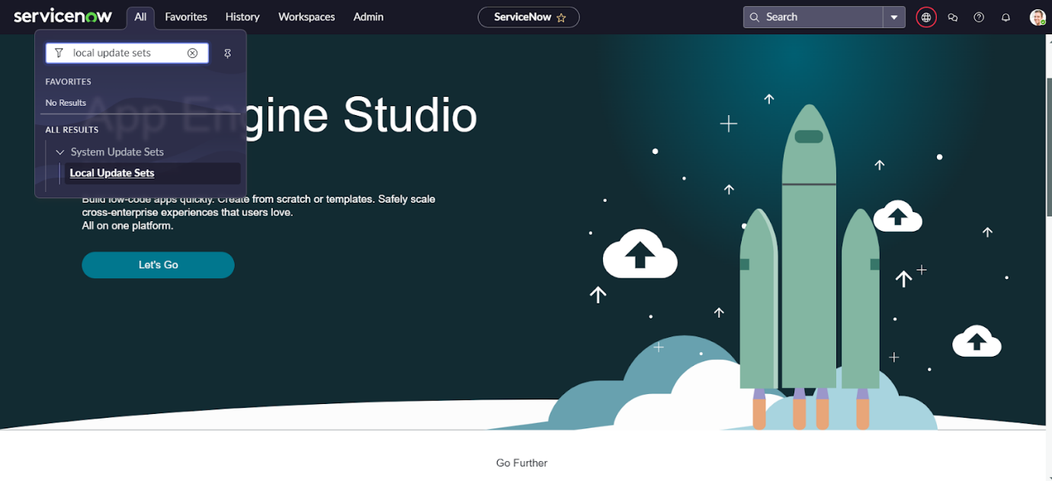

1. Click on new

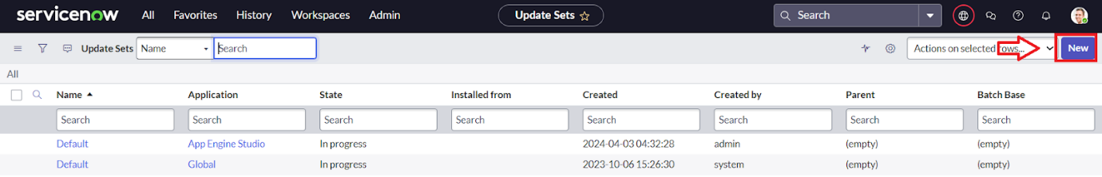

3.Enter the Details Name: Educational Organisation >> Click on Submit and make Current

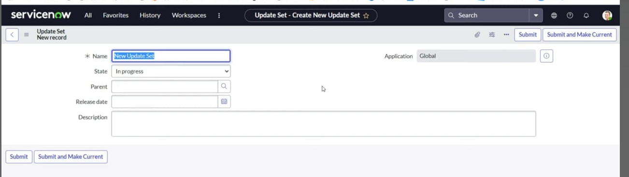

**Milestone 3: Creating a Table**

**Activity1: Creating Salesforce Table**

1. All >> Tables.

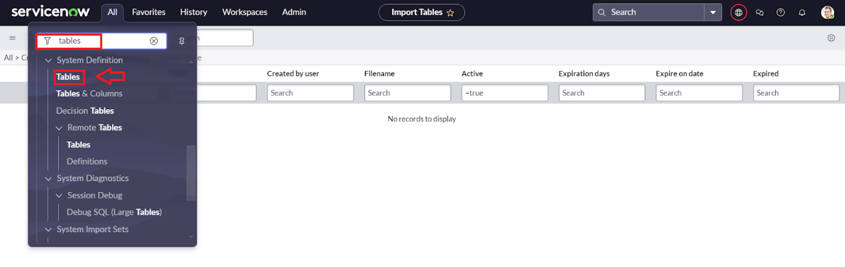

1. Click on new

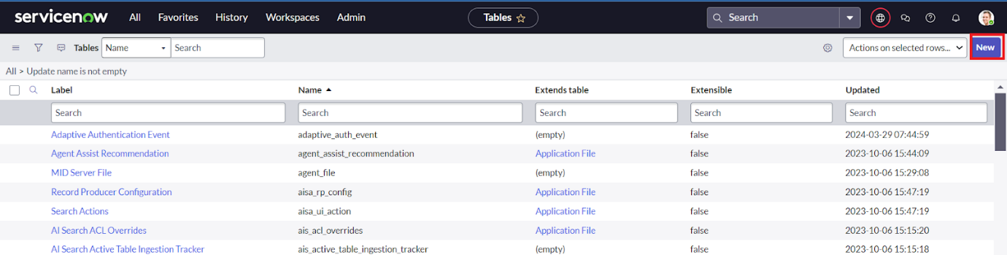

1. Enter the Label (Anything you want): Salesforce >> Click on Name it will Automatically generate Api name.

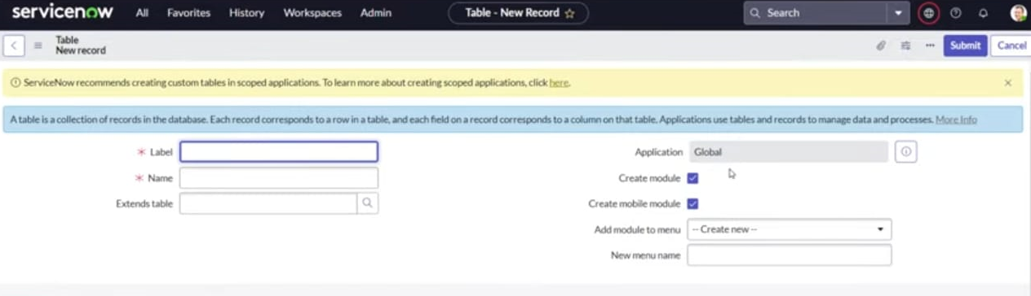

**Activity 2: Creating Admission Table**

1. Create an Admission Table with Columns given.
2. Select Extends Table >> Salesforce and also Select Add module to menu >> Salesforce.
3. Create Fields as shown

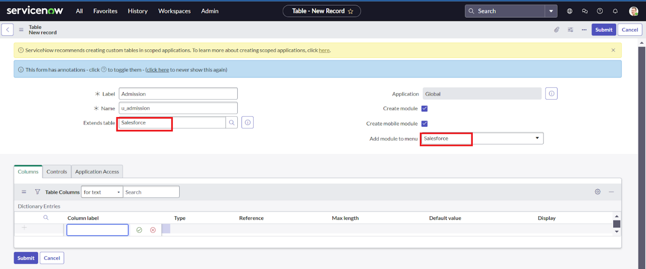

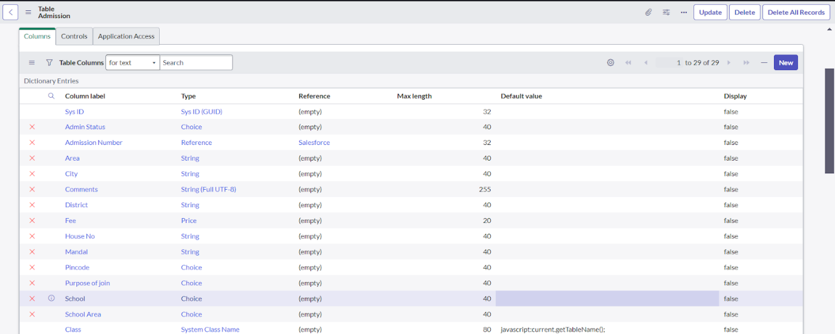

**Activity 3: Creating Student Progress Table**

1. Create a Student Progress Table with Columns given.
2. Select Add module to menu >> Salesforce.
3. Create Fields as shown:

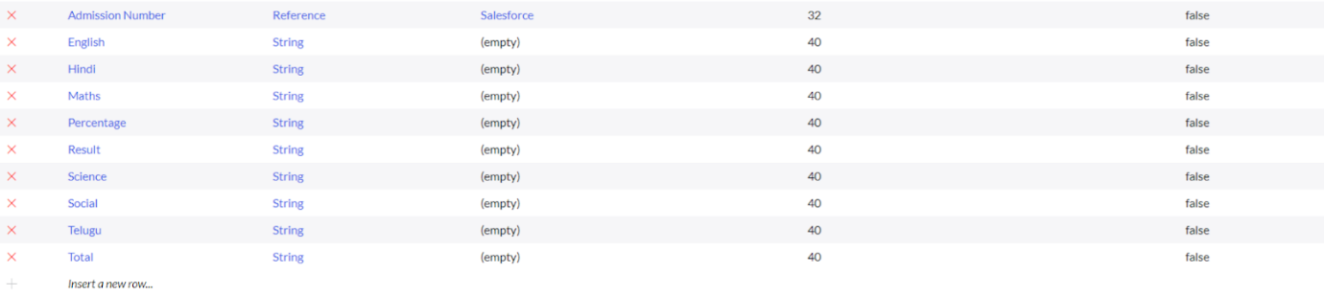

**Milestone 4: Form Layout**

**Activity 1: Configuring Table form for Student Progress Table**

1. In the Student Progress Table Page, Click onLayout form.

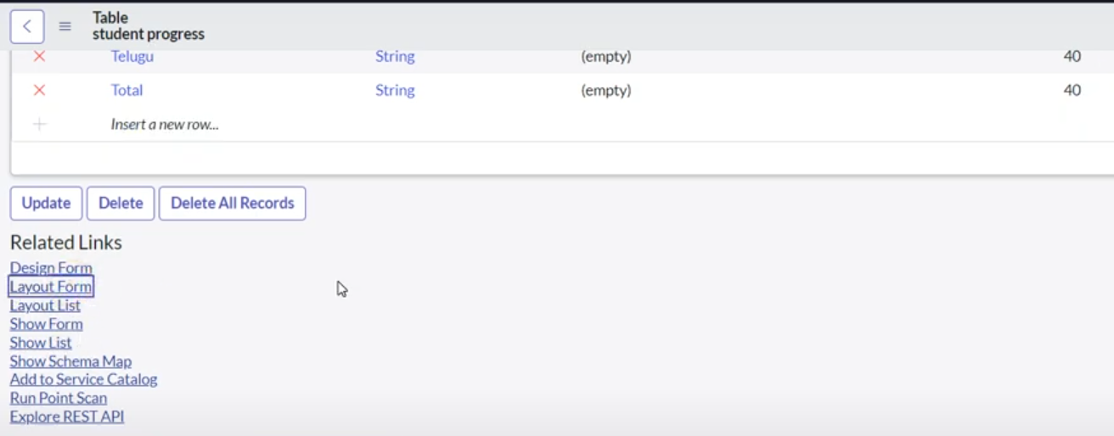

1. Click on Admission Number [+] **.**

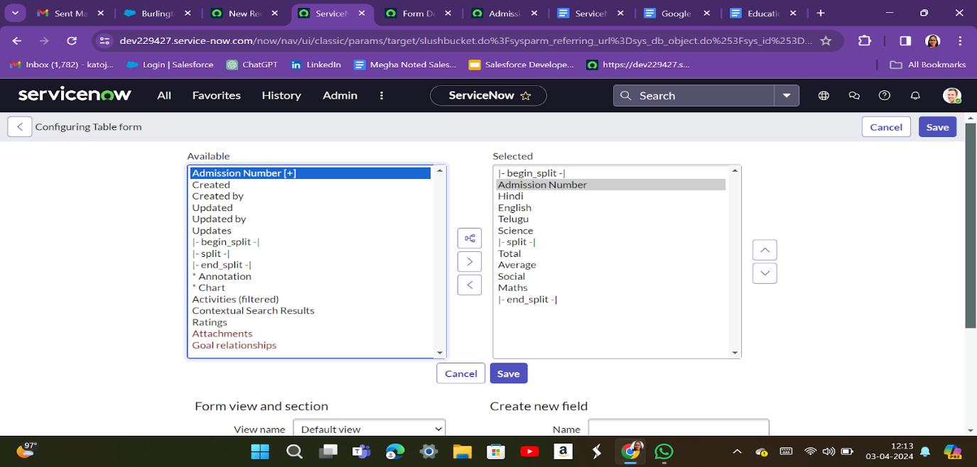

**Milestone 4: Form Design**

**Activity 1: Creating Form Design for Salesforce Table**

1. All >> System Definition >> Tables.
2. In Label Search for Salesforce and open

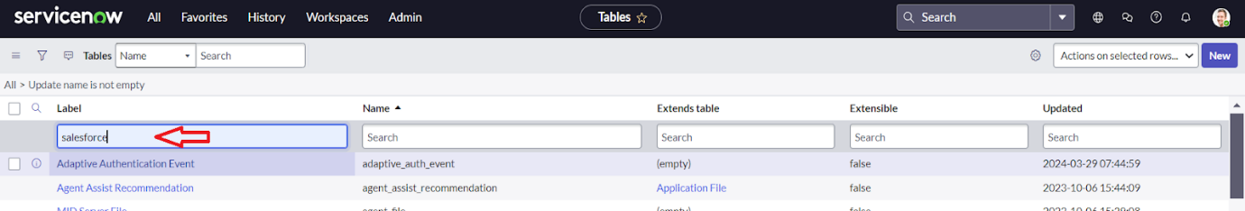

1. Right Click on top Toggle >> Configure >> Form Design.
2. In drop down select Salesforce(u_salesforce).
3. Drag and drop the fields to the left side as below.

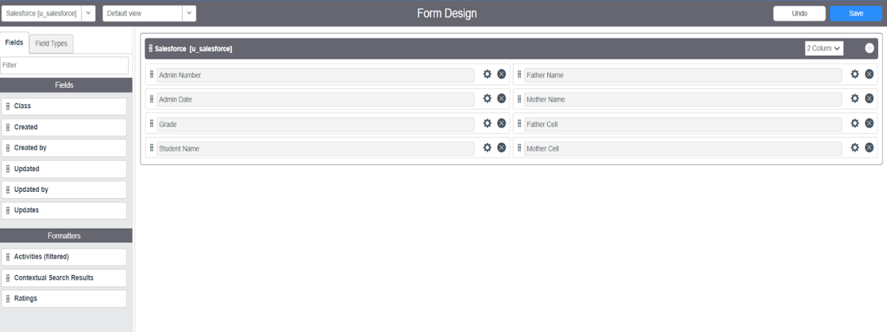

1. Save

**Activity 2: Creating Form Design for Admission Table**

Follow the same steps as Activity1, Configure the fields as below and Save.

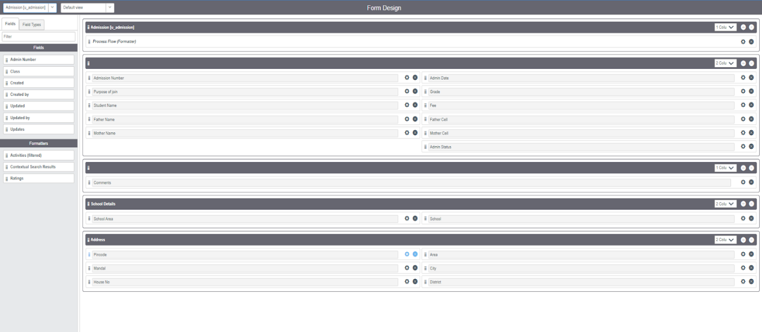

**Activity 3: Creating Form Design for Student progress Table**

Follow the same steps as Activity1, Configure the fields as below and Save**.**

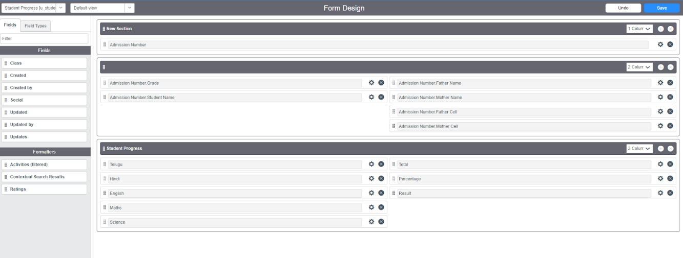

**Module 5: Number Maintenance**

**Activity 1: Creating Number Maintenance for Admin Number**

1. All >> Number Maintenance >> New

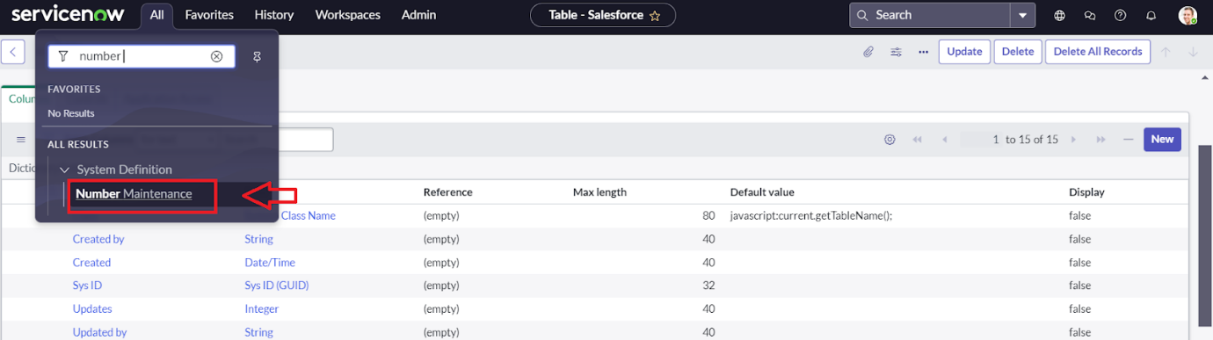

1. Fill the details >> Submit**.**

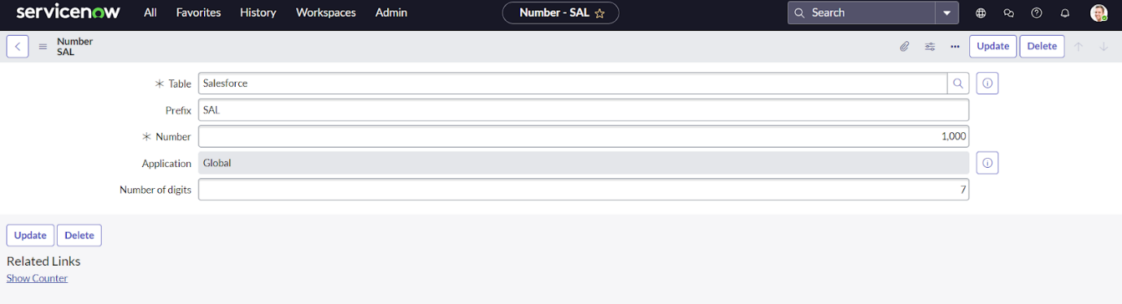

**Module 6: Process Flow**

**Activity 1: Creating Process Flow for Admission Table**

1. All >> Process Flow>> New.
2. Fill the Details as given Below

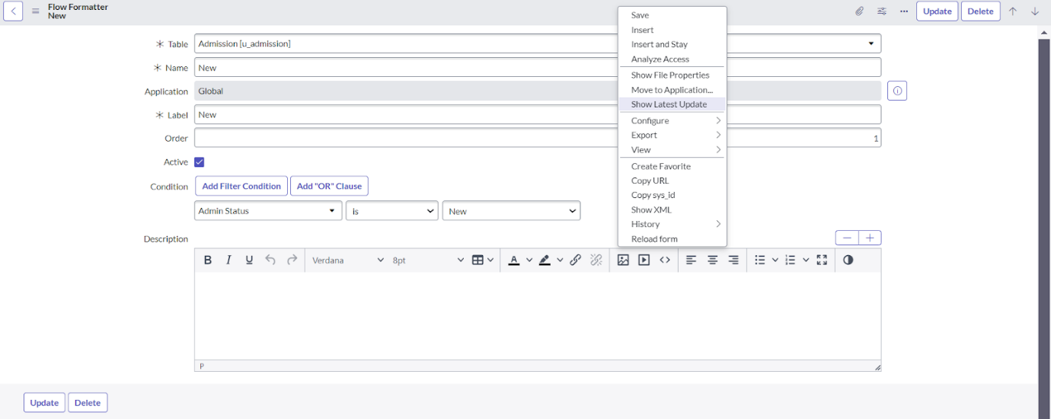

1. Right Click on toggle and click on the save.
2. Replace the Name and Label as below and click on Insert on stay.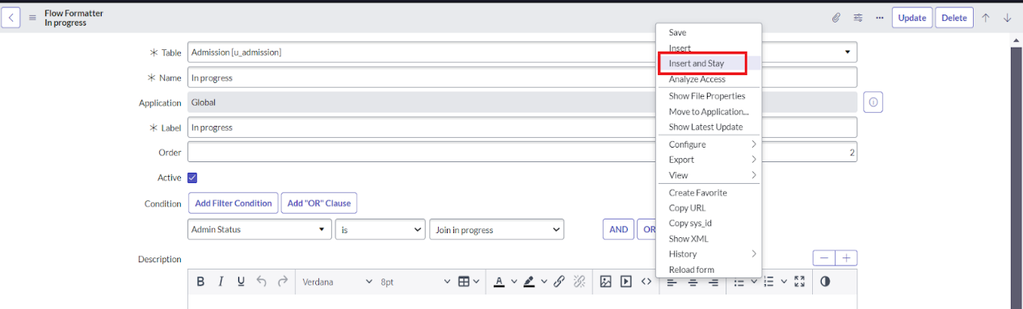
3. Replace the Name and Label in order and click on Insert on stay.

Joined >> Rejected >> Rejoined >> Closed >> Cancelled.

1. Order should be New >> InProgress >> Joined >> Rejected >> Rejoined >> Closed >> Cancelled.

**Module 7: Client Script**

**Activity 1: Creating Auto populate Client Scripts for Admission Table**

1. All >> Client Scripts >> New.
2. Fill the Details as given.

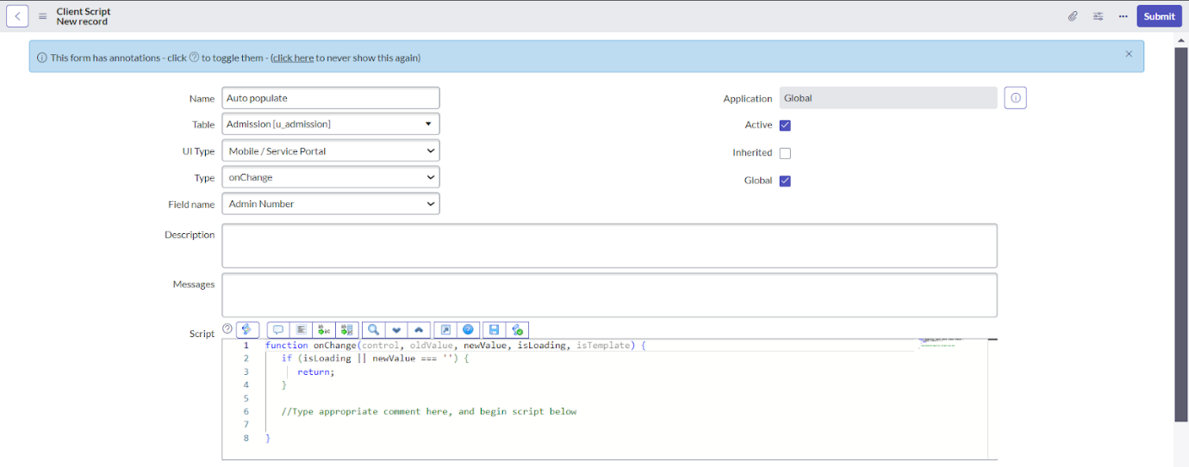

1. Write the Code as below, Enable Isolate script and Save.

function onChange(control, oldValue, newValue, isLoading, isTemplate) {

   if (isLoading || newValue === '') {

      return;

   }

  //Type appropriate comment here, and begin script below

   var a = g_form.getReference('u_admission_number');

   g_form.setValue('u_admin_date',a.u_admin_date);

   g_form.setValue('u_grade',a.u_grade);

   g_form.setValue('u_student_name',a.u_student_name);

   g_form.setValue('u_father_name',a.u_father_name);

   g_form.setValue('u_mother_name',a.u_mother_name);

   g_form.setValue('u_father_cell',a.u_father_cell);

   g_form.setValue('u_mother_cell',a.u_mother_cell);

 g_form.setDisabled('u_admin_date',a.u_admin_date);

   g_form.setDisabled('u_grade',a.u_grade);

   g_form.setDisabled('u_student_name',a.u_student_name);

   g_form.setDisabled('u_father_name',a.u_father_name);

   g_form.setDisabled('u_mother_name',a.u_mother_name);

   g_form.setDisabled('u_father_cell',a.u_father_cell);

   g_form.setDisabled('u_mother_cell',a.u_mother_cell);

}

**Activity 2:** **Creating Pincode Update Client Scripts for Admission Table**

1. Fill the Details as given.

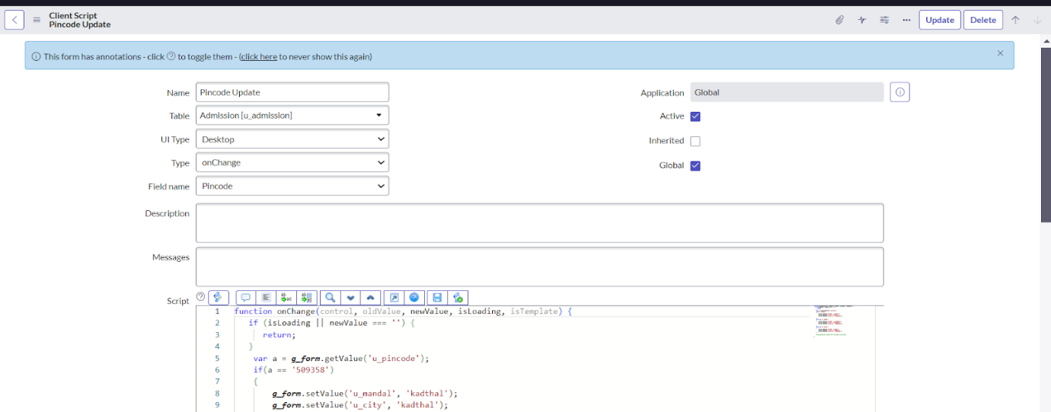

1. Write the Code as below, Enable Isolate script and Save.

function onChange(control, oldValue, newValue, isLoading, isTemplate) {

 if (isLoading || newValue === '') {

 return;

}

var a = g_form.getValue('u_pincode');

if(a == '509358')

{

g_form.setValue('u_mandal', 'kadthal');

g_form.setValue('u_city', 'kadthal');

g_form.setValue('u_district', 'RangaReddy');

}

else if(a == '500081')

{

g_form.setValue('u_mandal', 'karmanghat');

g_form.setValue('u_city', 'karmanghat');

g_form.setValue('u_district', 'RangaReddy');

}

else if(a == '500079')

{

g_form.setValue('u_mandal', 'Abids');

g_form.setValue('u_city', 'AsifNagar');

g_form.setValue('u_district', 'Hyderabad');

}

//Type appropriate comment here, and begin script below

}

**Activity 3: Creating Disable Fields Client Scripts for Student progress Table**

1. Fill the Details as given.

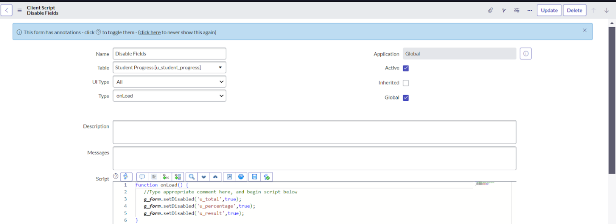

1. Write the Code as below, Enable Isolate script and Save.

function onLoad() {

   //Type appropriate comment here, and begin script below

   g_form.setDisabled('u_total',true);

   g_form.setDisabled('u_percentage',true);

   g_form.setDisabled('u_result',true);

}

**Activity 4: Creating Total Update Client Scripts for Student progress Table**

1. Fill the Details as given.

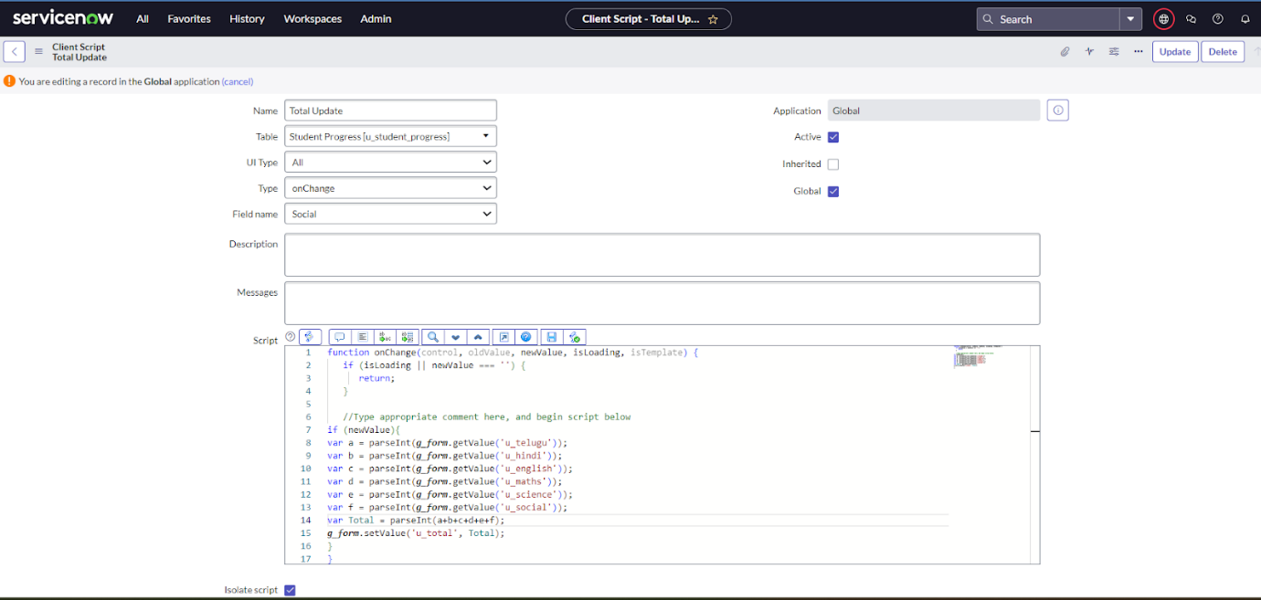

1. Write the Code as below, Enable Isolate script and Save.

function onChange(control, oldValue, newValue, isLoading, isTemplate) {

   if (isLoading || newValue === '') {

   return;

   }

  //Type appropriate comment here, and begin script below

if (newValue){

var a = parseInt(g_form.getValue('u_telugu'));

var b = parseInt(g_form.getValue('u_hindi'));

var c = parseInt(g_form.getValue('u_english'));

var d = parseInt(g_form.getValue('u_maths'));

var e = parseInt(g_form.getValue('u_science'));

var f = parseInt(g_form.getValue('u_social'));

var Total = parseInt(a+b+c+d+e+f);

g_form.setValue('u_total', Total);

}

}

**Activity 5:** **Creating Result Client Scripts for Student progress Table**

1. Fill the Details as given.

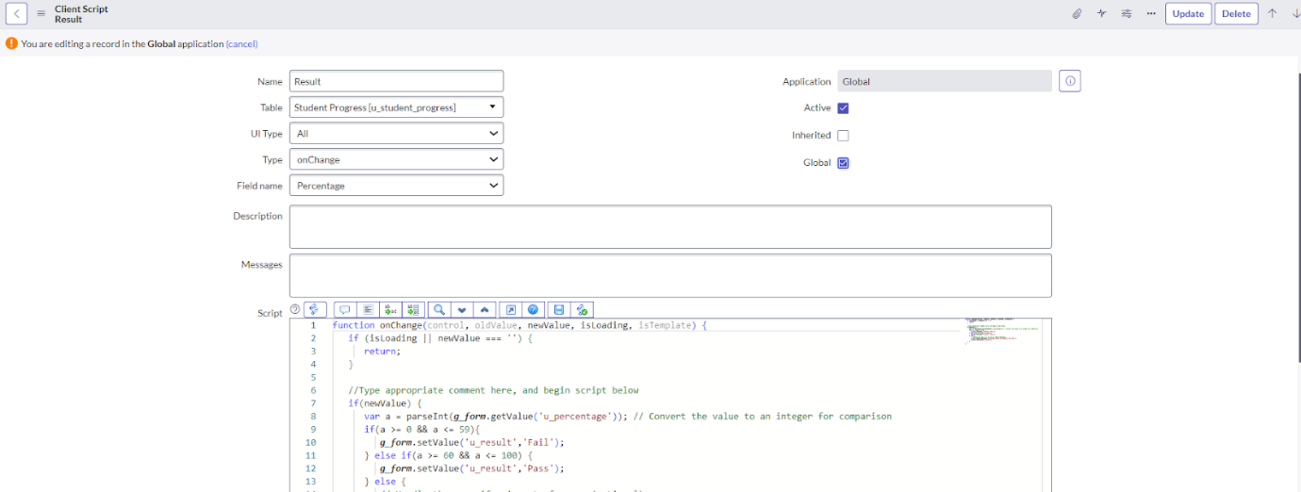

1. Write the Code as below, Enable Isolate script and Save.

function onChange(control, oldValue, newValue, isLoading, isTemplate) {

   if (isLoading || newValue === '') {

    return;

   }

   //Type appropriate comment here, and begin script below

   if(newValue) {

  var a = parseInt(g_form.getValue('u_percentage')); // Convert the value to an integer for comparison

   if(a >= 0 && a <= 59){

       g_form.setValue('u_result','Fail');

      } else if(a >= 60 && a <= 100) {

      g_form.setValue('u_result','Pass');

      } else {

       // Handle the case if a is out of range (optional)

       g_form.addErrorMessage('Percentage should be between 0 and 100.');

      g_form.clearValue('u_result');

      }

   }

}

**Activity 6:** **Creating Percentage Client Scripts for Student progress Table**

1. Fill the Details as given.

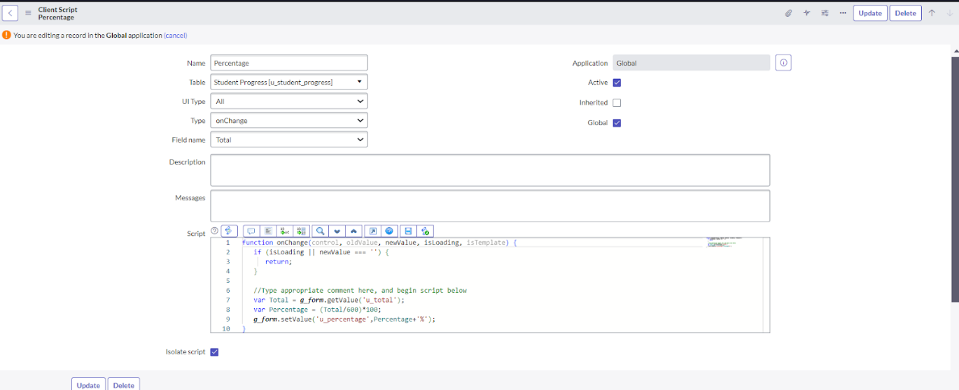

1. Write the Code as below, Enable Isolate script and Save.

function onChange(control, oldValue, newValue, isLoading, isTemplate) {

   if (isLoading || newValue === '') {

    return;

   }

  //Type appropriate comment here, and begin script below

   var Total = g_form.getValue('u_total');

   var Percentage = (Total/600)*100;

   g_form.setValue('u_percentage',Percentage+'%');

}

**Module 8: Result**

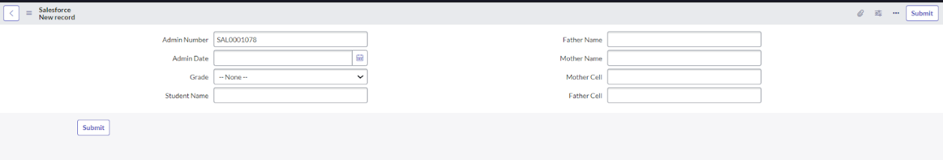

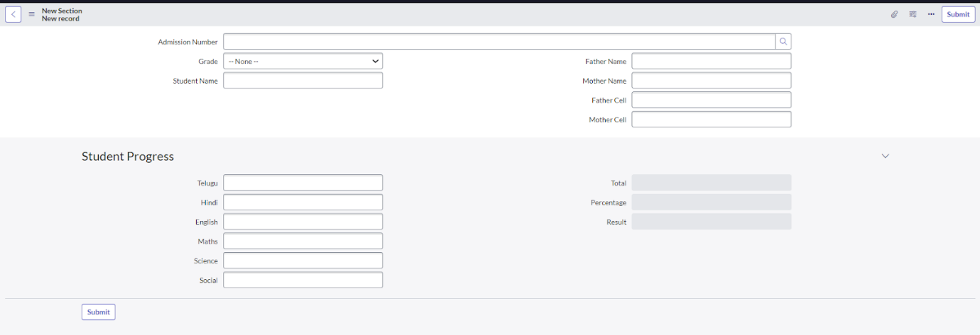

**Conclusion:**

Implementing ServiceNow in educational institutions helps tackle the challenges of disconnected systems and time-consuming manual processes. The platform simplifies workflows, integrates service management, and provides a centralized self-service portal. This leads to improved efficiency, transparency, and collaboration among departments. As a result, requests are resolved more quickly, administrative workload is reduced, and the overall experience for students, faculty, and staff is enhanced—ultimately fostering a more effective and organized academic environment.